**jMonkey 3D Scene Assignment**

**Student**: Patrick Walsh

**School**: University of Maryland Global Campus

**Course**: CMSC 325 6380

**Date**: 9/23/2021

**Professor**: Dr. Michael Elms

**Arrows: 3D Scene Description**

The Arrows 3D scene/game in JavaMonkey (JME) loads two "ships" represented as simple blue and red

boxes with an arrow object pointing from the blue ship down towards the red ship. When the user presses the Space bar, the arrow fires from the blue ship towards the red ship. The arrow stop when it hits the red ship. The user can then press 'R' to reset/reload the arrow. The y coordinate of the arrow is printed in the output window.

The inspiration for the game came as I was learning the basics of populating a scene in JME, creating spatials (objects), attaching spatials to nodes, and performing various transformations on the spatials. Coding in a 3D environment is new for me, and I as I thought about rendering objects and altering their scaling and location along the x, y, and z planes, I thought of warships firing missiles or arrows at each other. So I decided to create a simple scene that shows an arrow being fired at another object.

**Arrows: Gameplay**

When the scene is launched, the user sees 3 objects: the blue ship attached to the rootNode, the red ship attached to the rootNode, and an arrow spatial made up of a cylinder and two cones (domes) attached to a node. See screen shot below:

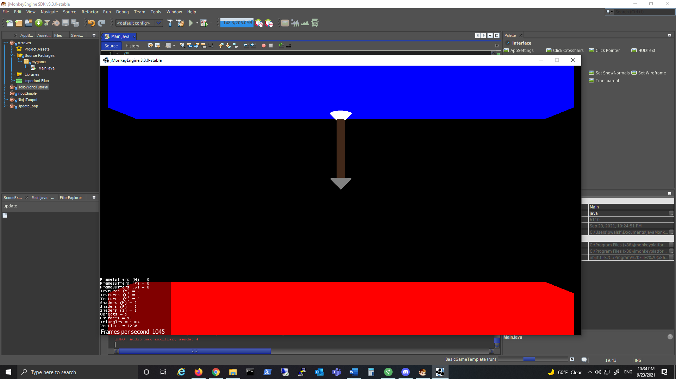

When the user presses the Space bar, the arrow fires, moving rapidly downward toward the red ship. When the arrowhead reached the red ship, the arrow stops, as if it has punctured the side of the ship and stopped. See screen shots below:

*Arrow in midflight.*

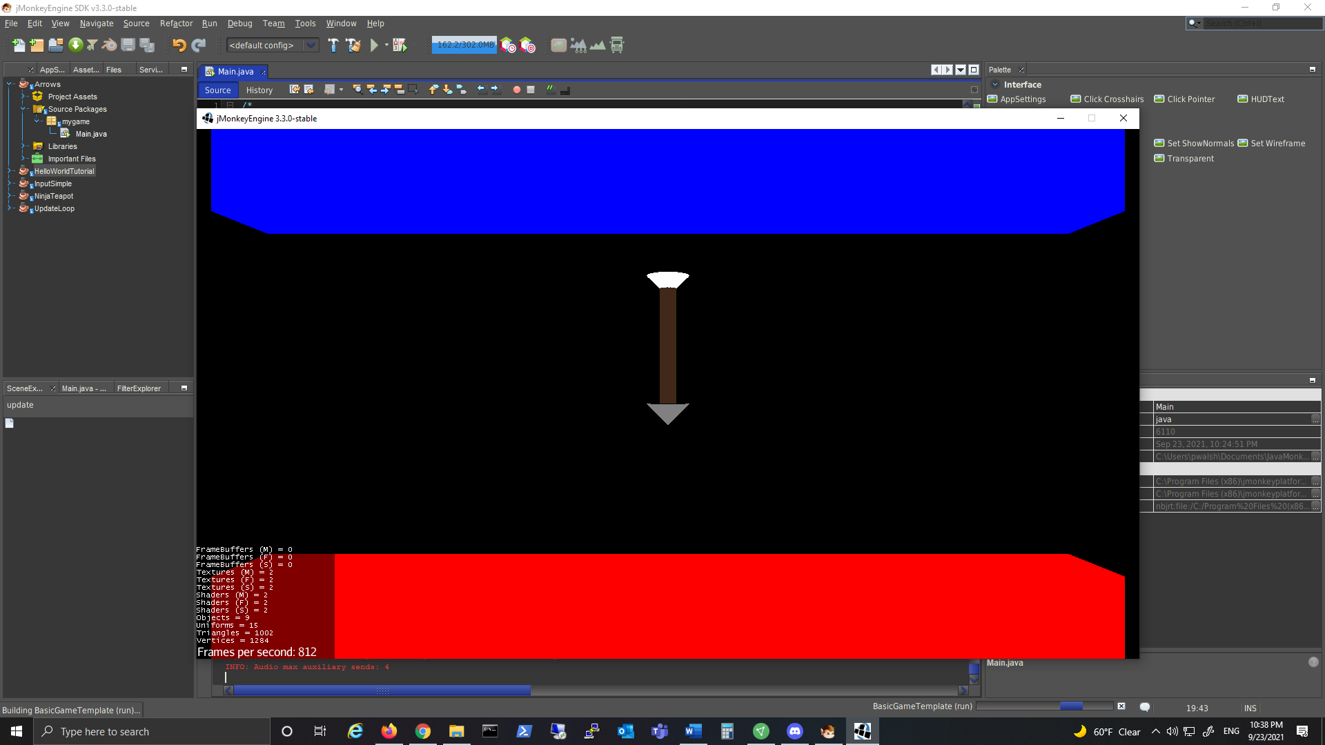

*Arrow stuck in red ship.*

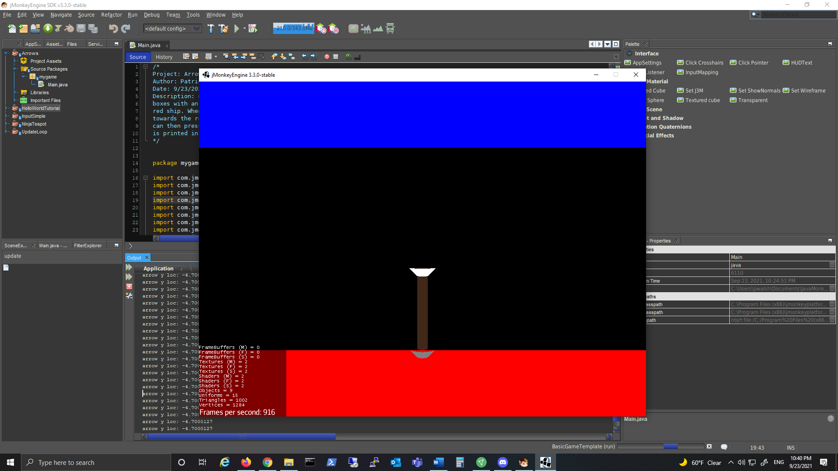

The output window tracks the y coordinate of the arrow’s location in real time as it is fired. Once the arrow reaches -4.7 in the 7 direction, the arrow stops. See screen shot below:

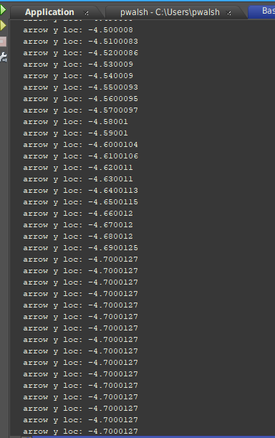

After the user presses the ‘R’ key, the arrow is reset back to the starting position and the user has the option of firing the arrow again. See the screen shot below:

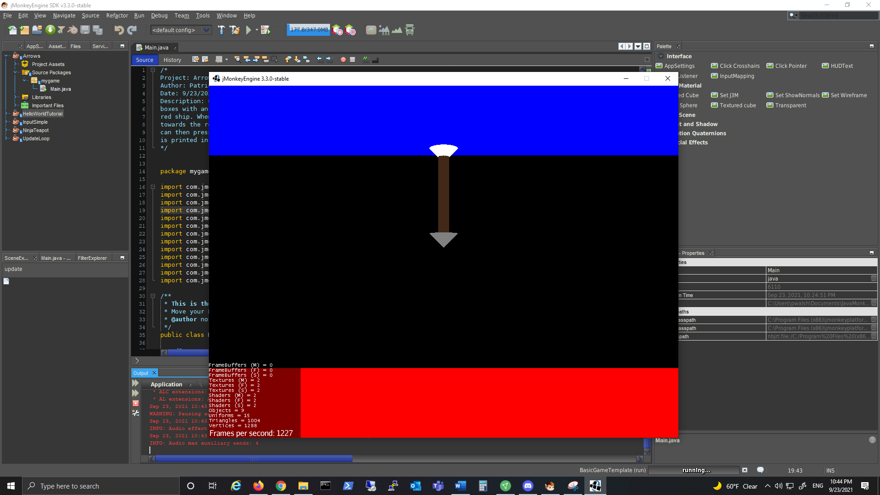

**Coding Sources used:**

<https://wiki.jmonkeyengine.org/docs/3.3/tutorials/beginner/hello_simpleapplication.html>

<https://wiki.jmonkeyengine.org/docs/3.3/tutorials/beginner/hello_node.html>

<https://wiki.jmonkeyengine.org/docs/3.3/tutorials/beginner/hello_asset.html>

<https://wiki.jmonkeyengine.org/docs/3.3/tutorials/beginner/hello_main_event_loop.html>

<https://wiki.jmonkeyengine.org/docs/3.3/tutorials/beginner/hello_input_system.html>

<https://javadoc.jmonkeyengine.org/v3.3.0-beta1/com/jme3/scene/shape/Dome.html>

<https://javadoc.jmonkeyengine.org/v3.3.0-beta1/com/jme3/scene/shape/Cylinder.html>

<https://wiki.jmonkeyengine.org/docs/3.4/core/scene/shape/shape.html>